* **Hospital Data**

1. Doctor Attributes:

# ID

* + Name
  + Age
  + Phone 2.Nursing Attributes:

# ID

* + Name
  + Departement 3.patient

Attributes:

# ID

* + Name
  + Date of birth
  + gender 4.supervisor Attributes:

# ID

* + Fname
  + Lname
  + Departement 5.Medicine Attributes:

# ID

* + Name * Price
  + Type

3-ERD,MAPPING

* **ERD**

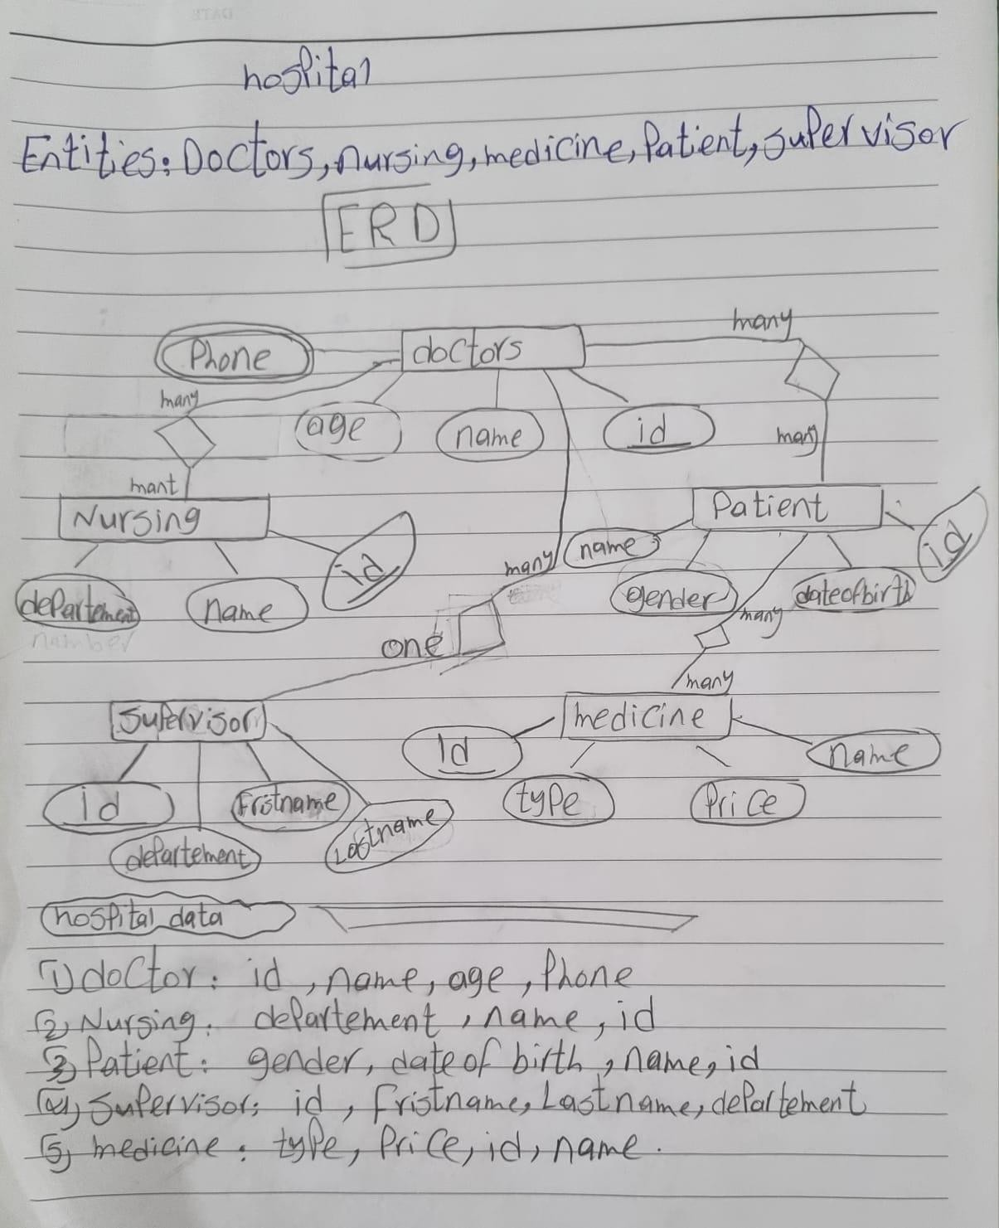

* **mapping**

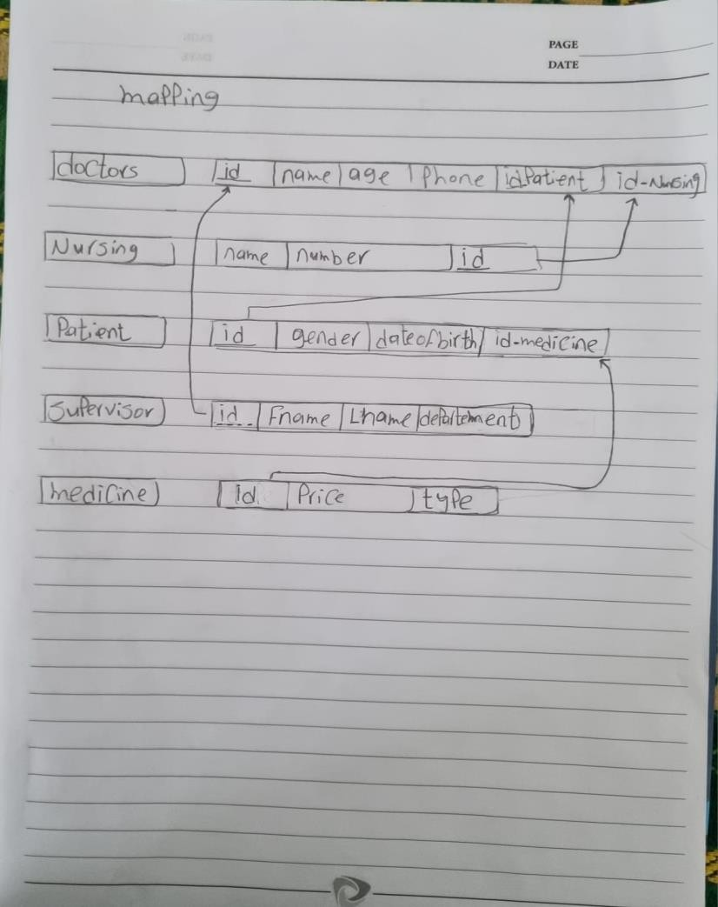

* **normalization**

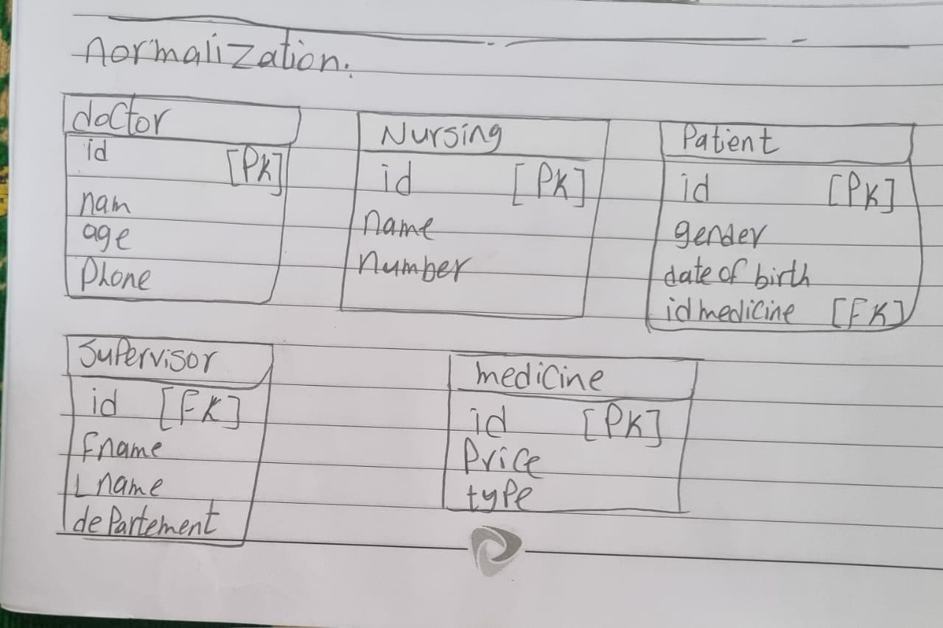

**\*Question 5:**

**\* create tables and insert data**

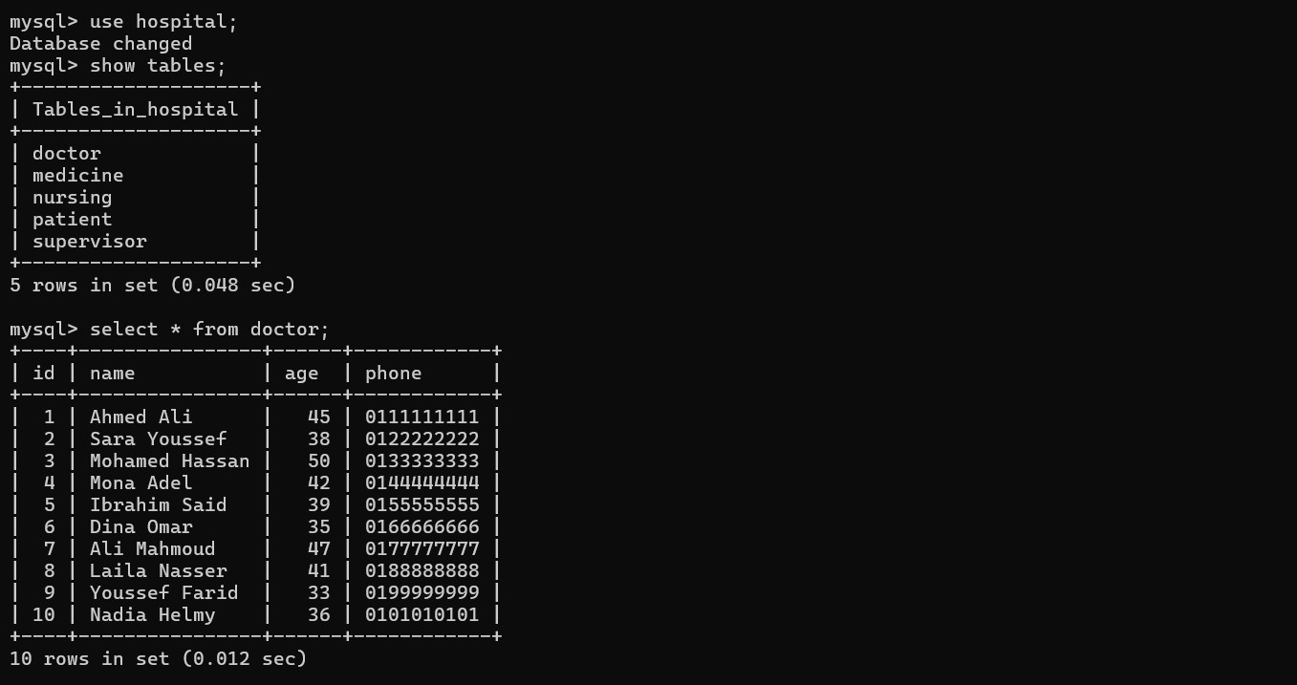

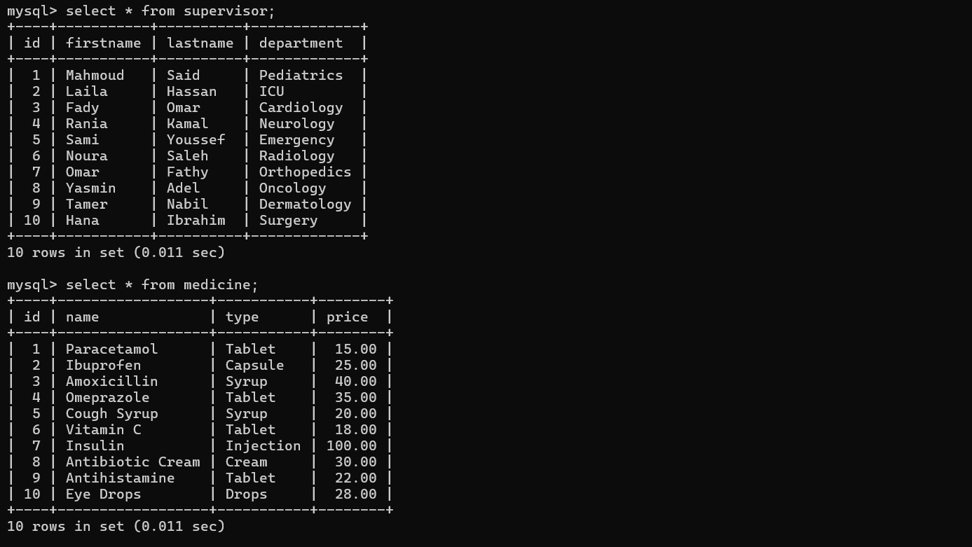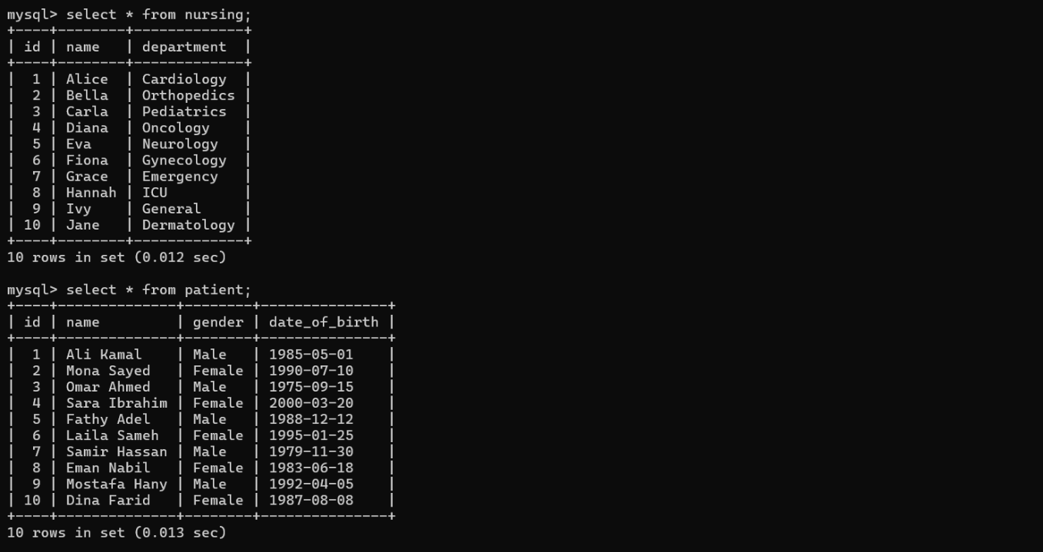

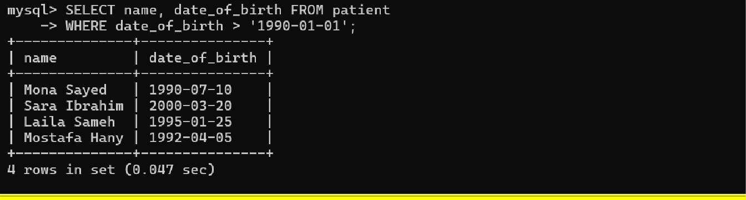

* **question 6:**

